Part Number: PT347-1M16X

Kit Contents

|  |  |  |
| --- | --- | --- |
| Item # | Quantity Reqd. | Description |
| 1 | 1 | Convenience Net |
| 2 | 1 | Hardware Bag |
| 3 |  |  |
|  |  |  |

Hardware Bag Contents

|  |  |  |
| --- | --- | --- |
| Item # | Quantity Reqd. | Description |
| 1 | 2 | T-Anchor Assembly |
| 2 | 2 | Nylon Spacers |
| 3 | 2 | Panel Clips |
|  |  |  |

Additional Items Required For Installation

|  |  |  |
| --- | --- | --- |
| Item # | Quantity Reqd. | Description |
| 1 |  |  |
| 2 |  |  |
| 3 |  |  |
|  |  |  |

Conflicts

|  |
| --- |
|  |

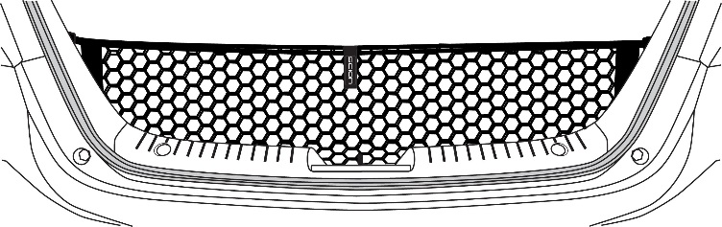Recommended Tools

Care must be taken when installing this accessory to ensure damage does not occur to the vehicle. The installation of this accessory should follow approved guidelines to ensure a quality installation.

These guidelines can be found in the "Accessory

Installation Practices" document.

This document covers such items as:-

• Vehicle Protection (use of covers and blankets, cleaning chemicals, etc.).

• Safety (eye protection, rechecking torque procedure, etc.).

• Vehicle Disassembly/Reassembly (panel removal, part storage, etc.).

• Electrical Component Disassembly/Reassembly (battery disconnection, connector removal, etc.).

Please see your Toyota dealer for a copy of this document.

|  |  |
| --- | --- |
| Personal & Vehicle Protection | Notes |
| None |  |
|  |  |
|  |  |
| Special Tools | Notes |
| None |  |
|  |  |
|  |  |
| Installation Tools | Notes |
| Trim Plug Removal Tool |  |
|  |  |
|  |  |
| Special Chemicals | Notes |
| None |  |
|  |  |
|  |  |

General Applicability

|  |
| --- |
|  |

Recommended Sequence of Application

|  |  |
| --- | --- |
| Item # | Accessory |
|  |  |

\*Mandatory

Vehicle Service Parts (may be required for reassembly)

|  |  |  |
| --- | --- | --- |
| Item # | Quantity Reqd. | Description |
|  |  |  |

Legend

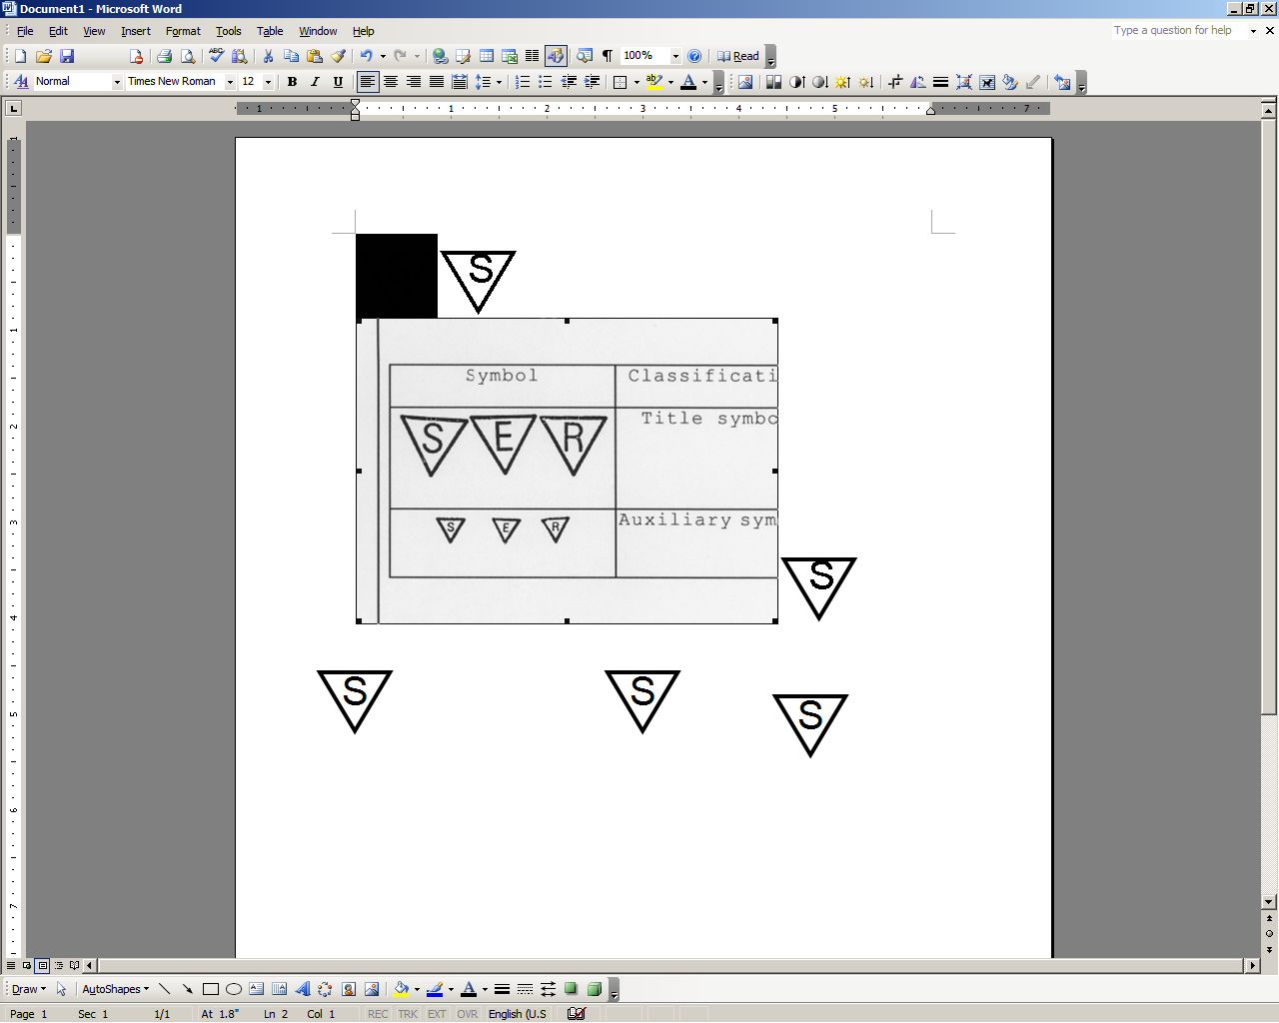toolcaution_2safety_2stop_2

**STOP:** Damage to the vehicle may occur. Do not proceed until process has been complied with.

**OPERATOR SAFETY:** Use caution to avoid risk of injury.

**CAUTION:** A process that must be carefully observed in order to reduce the risk of damage to the accessory/vehicle and to ensure a quality installation.

**TOOLS & EQUIPMENT:** Used in Figures calls out the specific tools and equipment recommended for this process.

**REVISION MARK:** This mark highlights a change in installation with respect to previous issue.  
  
**SAFETY TORQUE:** This mark indicates that torque is related to safety.

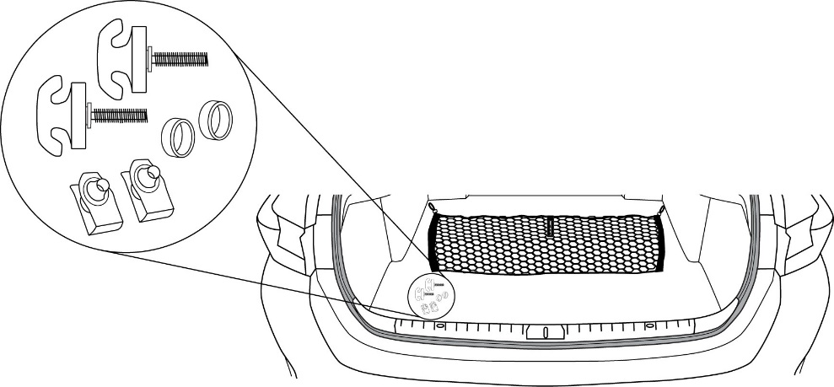

**TOOLS REQUIRED:**

**trIM PLUG REMOVAL TOOL**



1

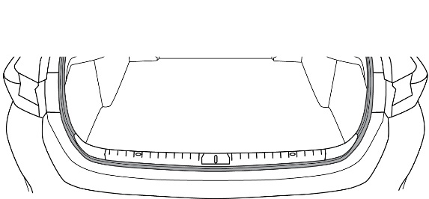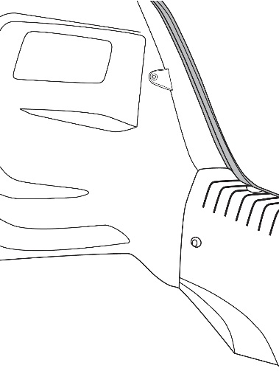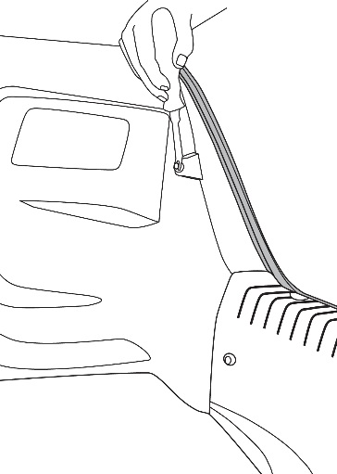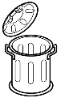

**Repeat on driver side**



2

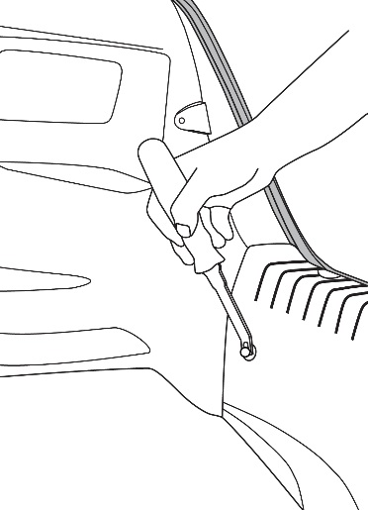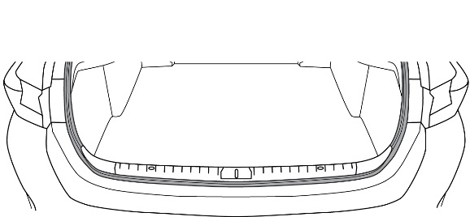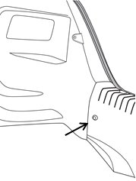

**retain clips –**

**Repeat on driver side**



5

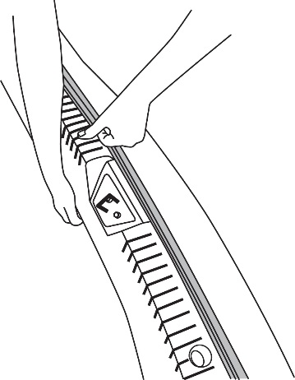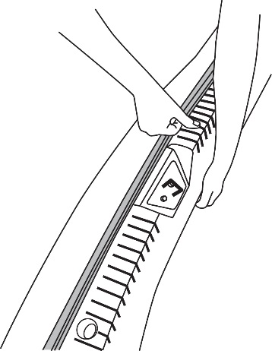

**Driver side**

**passenger side**

4

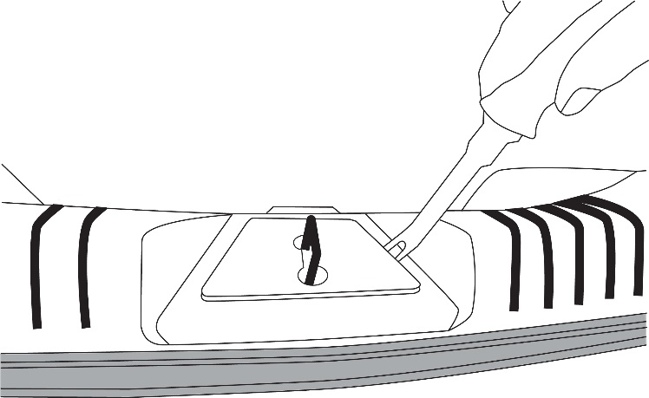

3

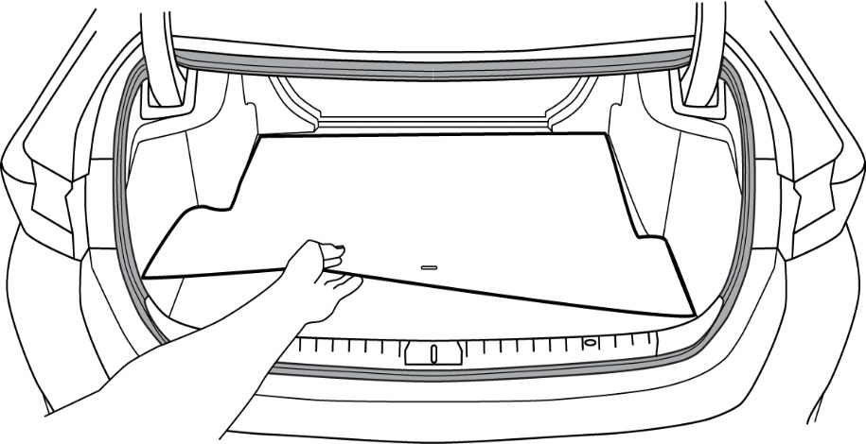

**remove**

6

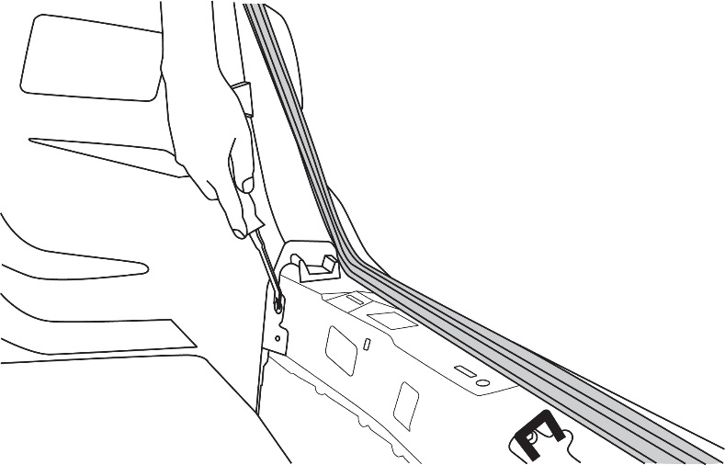

**Retain clips –**

**repeat on driver side**

7

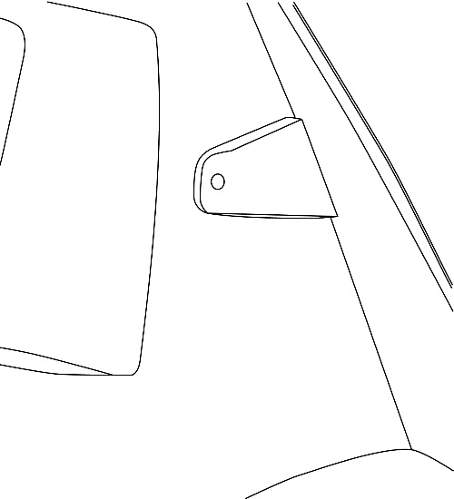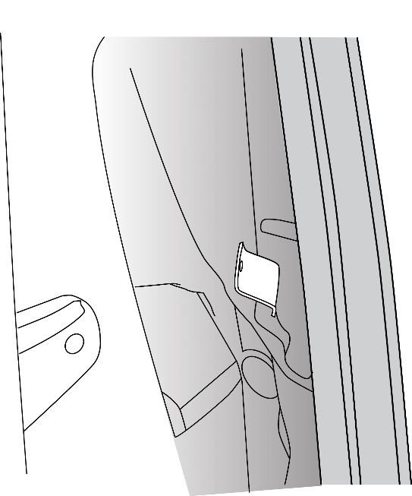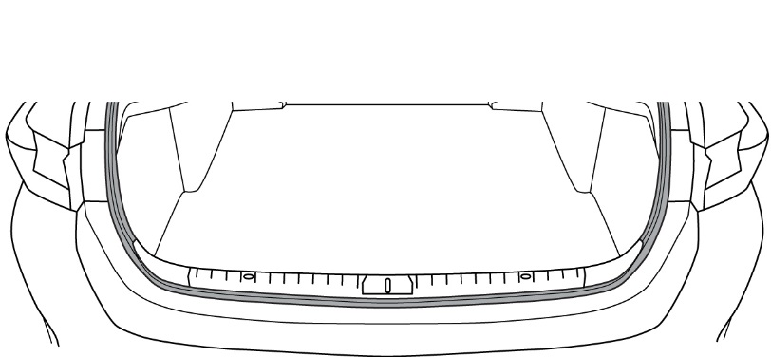

a

b

**pull back panel**

**locate tab**

**repeat on driver side**

b

8

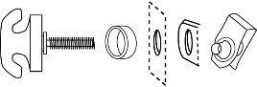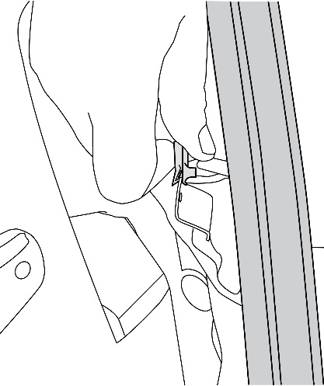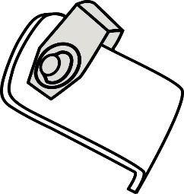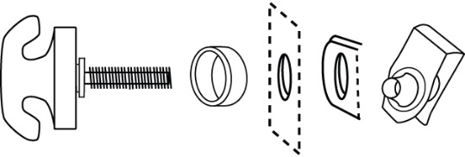

a

**driver side orientation**

**10 o’clock – rear view**

**passenger side orientation**

**2 o’clock – rear view**

**install panel clip on tab**

**panel clip**

**tab**

**panel**

**nylon spacer**

**t-anchor**

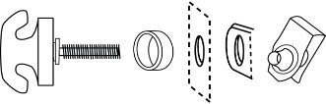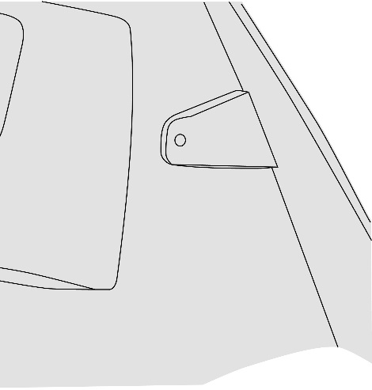

**replace panel**

9

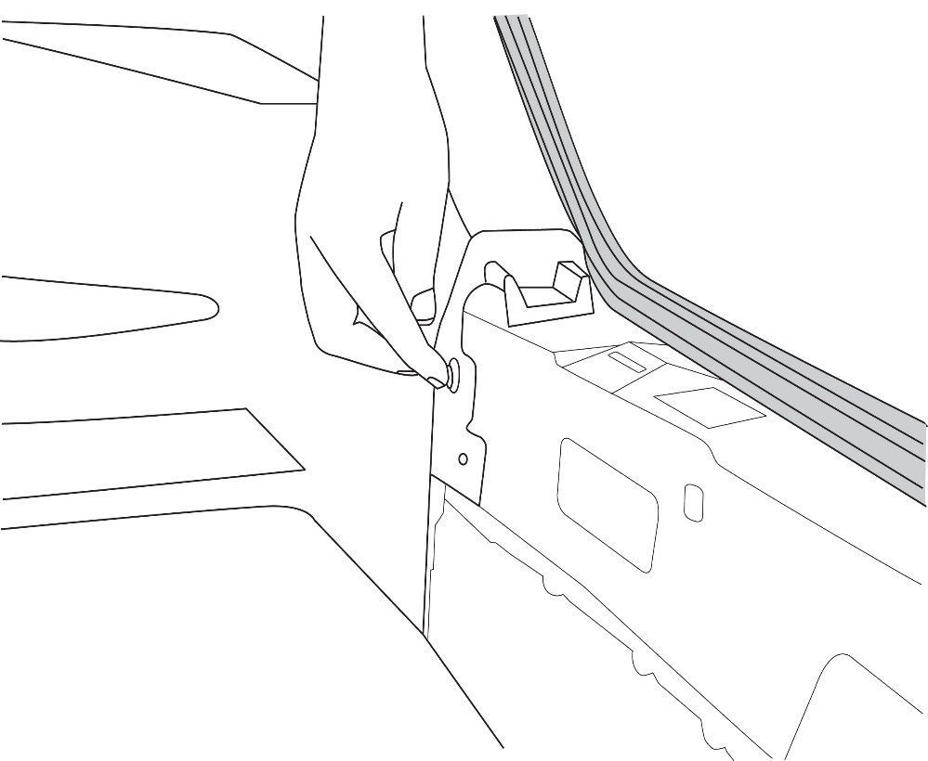

**repeat on driver side**

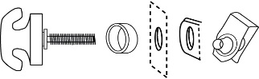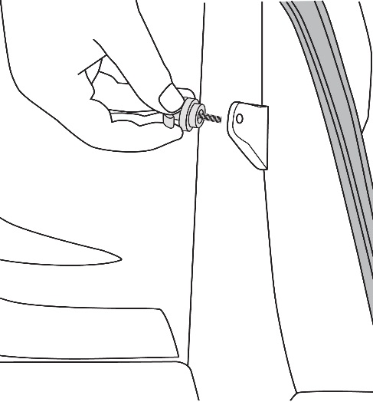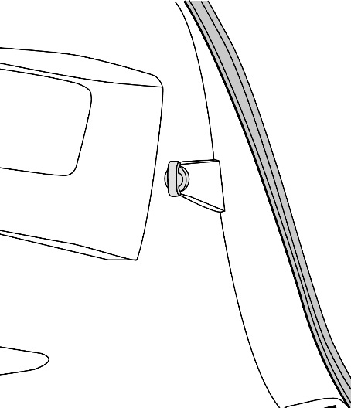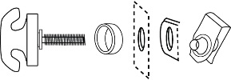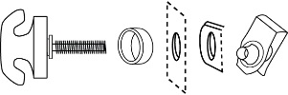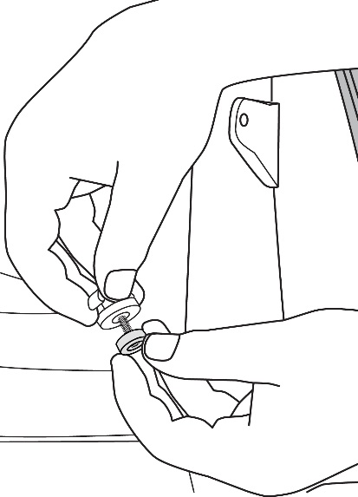

c

d

e

**repeat on driver side**

10

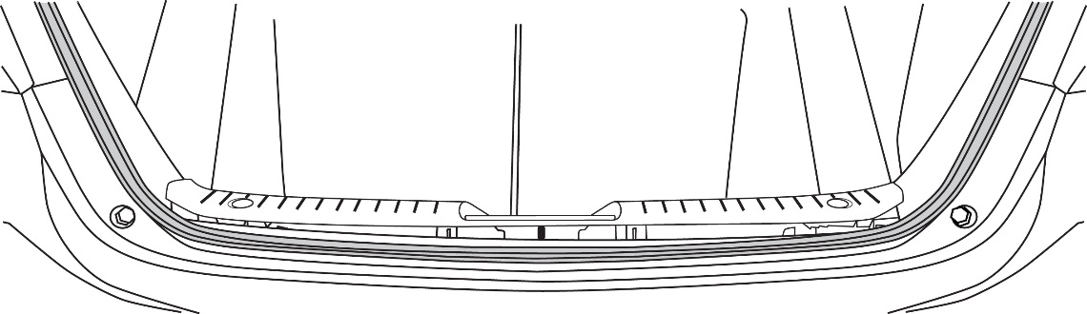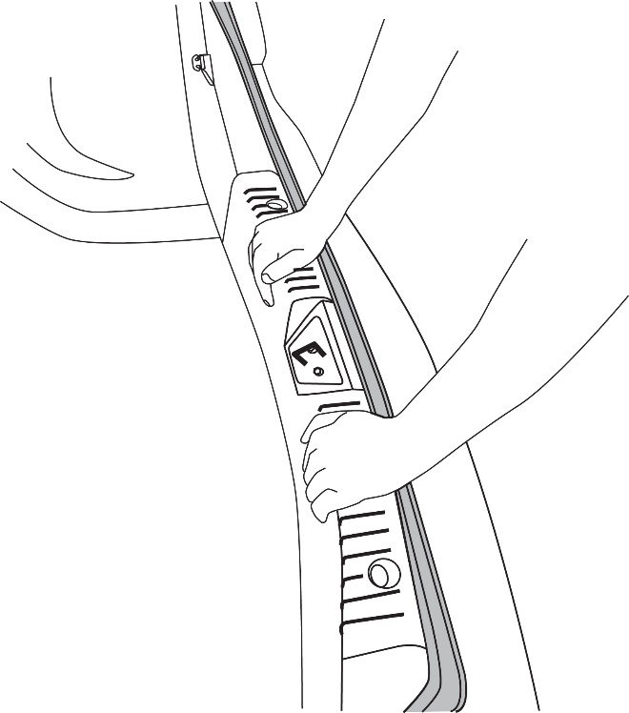

a

b

11

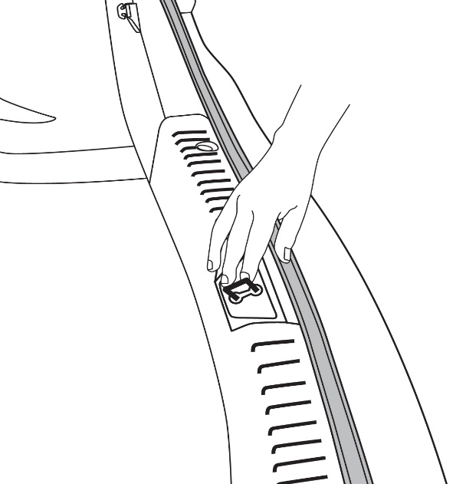

12

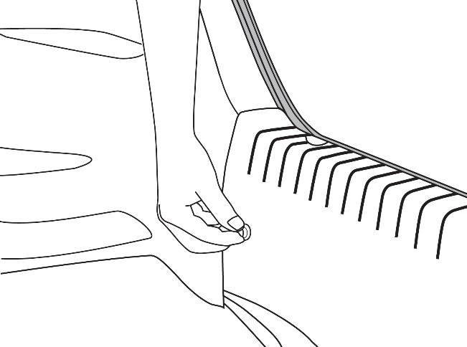

**repeat on driver side**

13



**replace**

14

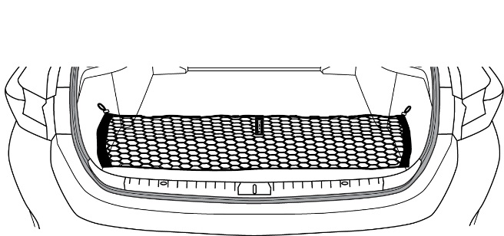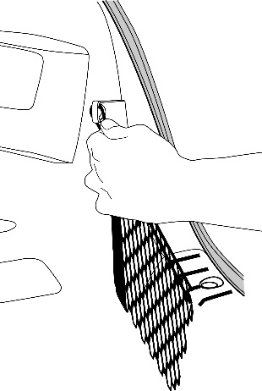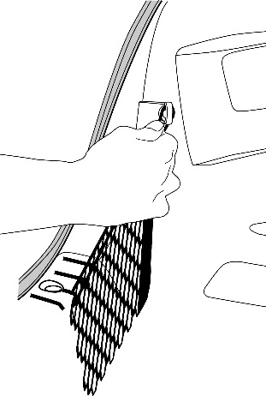

15

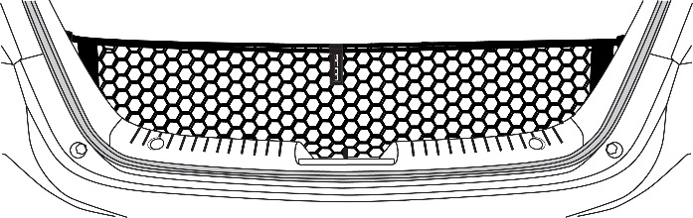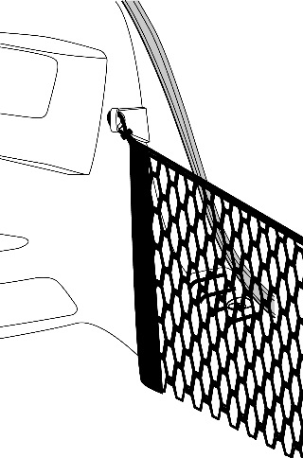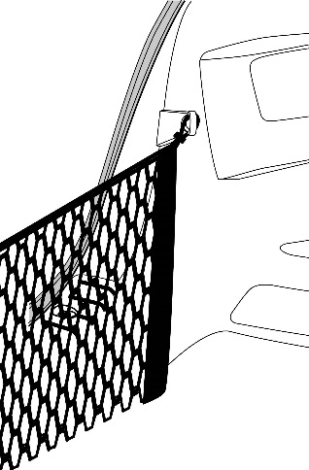

Accessory Function Checks

Confirm that the net is attached properly to the anchor points in the vehicle

Vehicle Function Checks

Vehicle trunk operation

Vehicle Appearance Check

After accessory installation and removal of protective cover(s), perform a visual inspection.

Confirm net handle is facing toward the rear of the vehicle

Confirm upper loops at the top of the net are attached to the upper T-Anchors of the vehicle

Confirm vehicle trunk opens & closes properly

Ensure no damage (including scuffs and scratches) was caused during the installation process.

(For PPO installations, refer to TMS Accessory Quality Shipping Standard.)